ROBERT OPERATOR CODE

clc

clear all

close

a=imread('C:\Users\fy\Desktop\toyobjects.png');

a=double(a)

[r c]=size(a)

w1=[1 0; 0 -1]

w2=[0 1; -1 0]

for x=2:1:r-1

for y=2:1:c-1

a1(x,y)=w1(1)\*a(x,y)+w1(2)\*a(x,y+1)+w1(3)\*a(x+1,y)+w1(4)\*a(x+1,y+1);

a2(x,y)=w2(1)\*a(x,y)+w2(2)\*a(x,y+1)+w2(3)\*a(x+1,y)+w2(4)\*a(x+1,y+1);

end

end

a3=a1+a2

figure,imshow(uint8(a1))

figure,imshow(uint8(a2))

figure,imshow(uint8(a3))

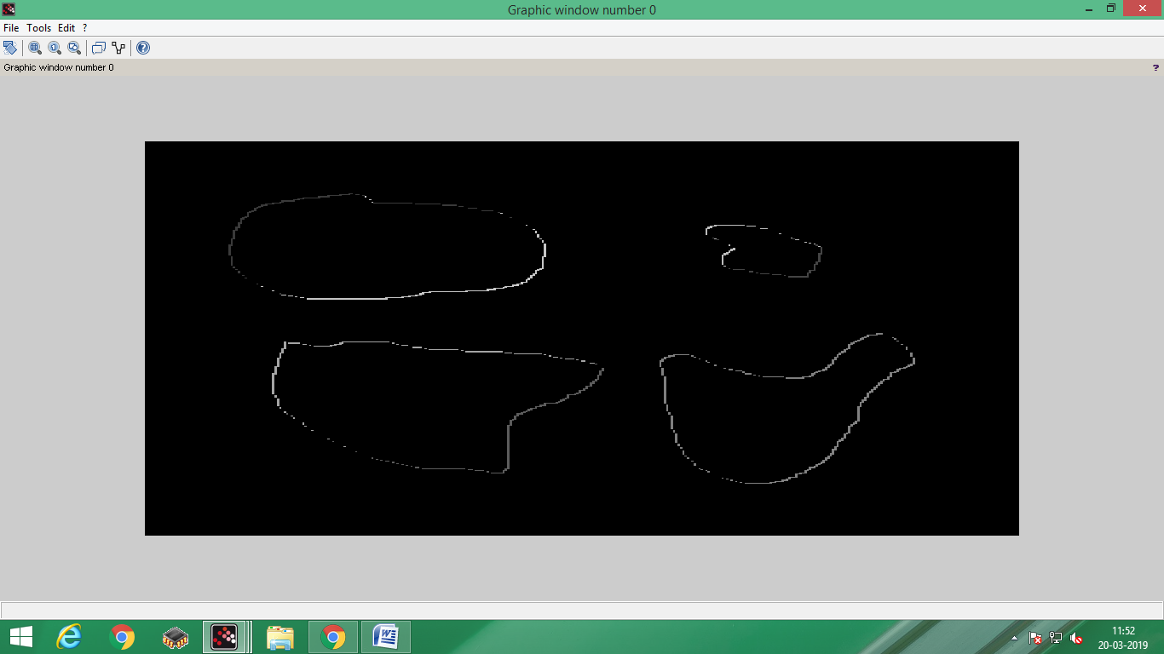

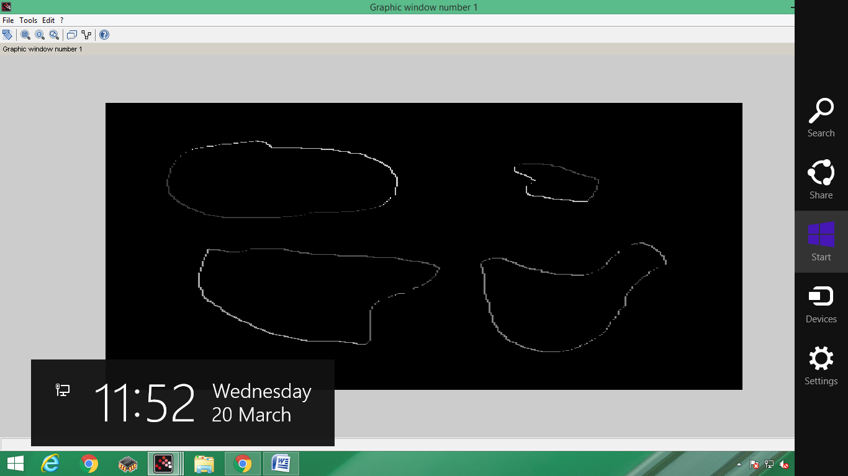

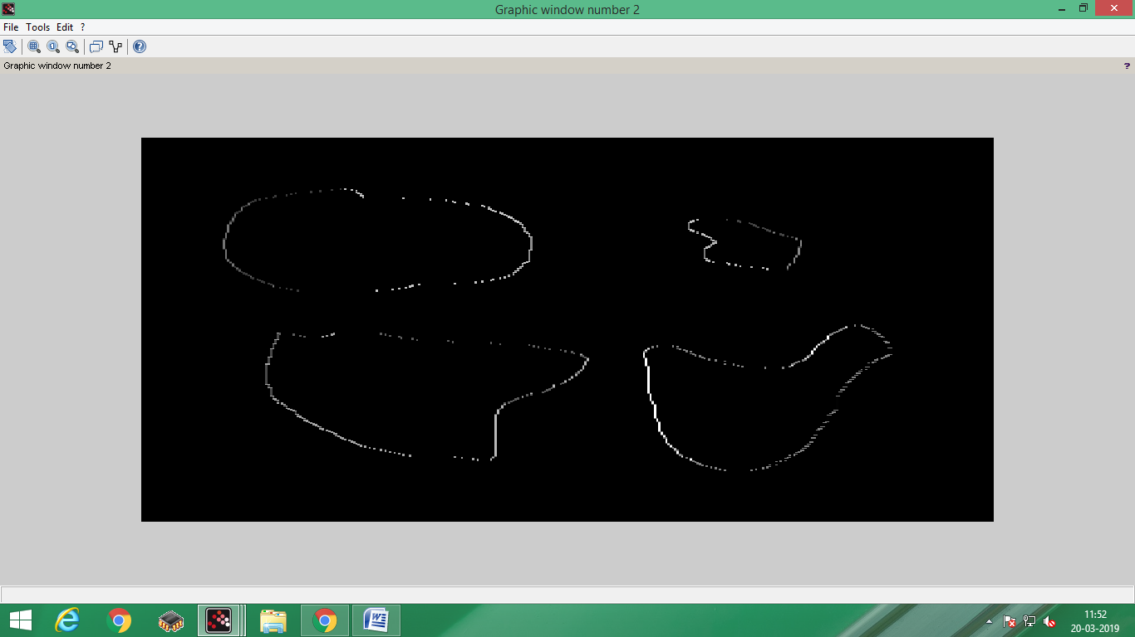

ROBERTS MASK

clc

clear all

close

a=imread('C:\Users\fy\Desktop\toyobjects.png');

a=double(a)

[r c]=size(a)

w1=[1 0; 0 -1]

w2=[0 1; -1 0]

w3=w1+w2

for x=2:1:r-1

for y=2:1:c-1

a3(x,y)=w3(1)\*a(x,y)+w3(2)\*a(x,y+1)+w3(3)\*a(x+1,y)+w3(4)\*a(x+1,y+1);

*//a2(x,y)=w2(1)\*a(x,y)+w2(2)\*a(x,y+1)+w2(3)\*a(x+1,y)+w2(4)\*a(x+1,y+1);*

end

end

*//a3=a1+a2*

*//figure,imshow(uint8(a1))*

*//figure,imshow(uint8(a2))*

figure,imshow(uint8(a3))

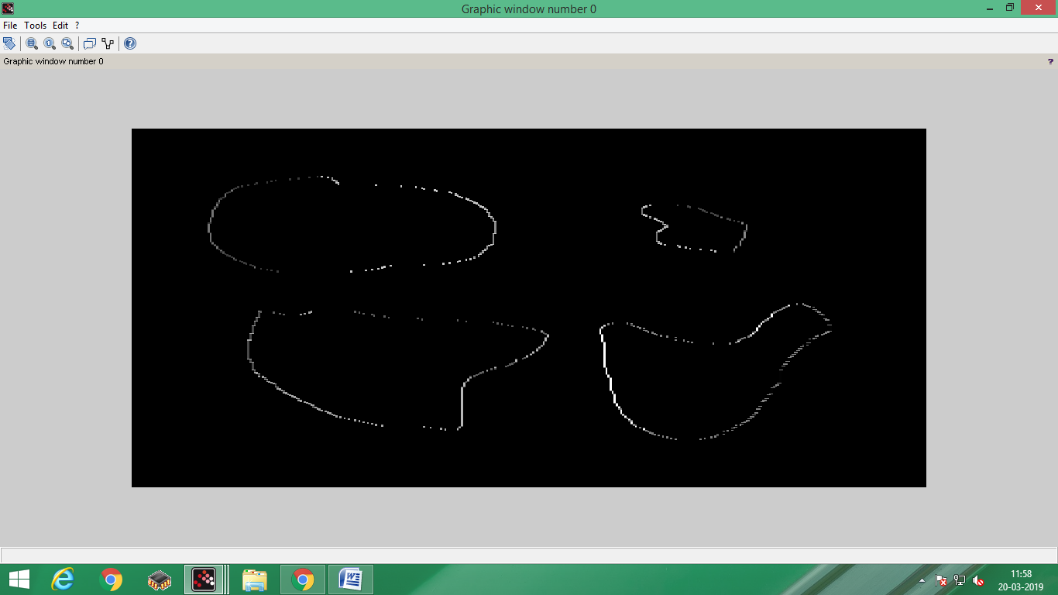

clc

clear all

close

a=imread('C:\Users\fy\Desktop\toyobjects.png');

a=double(a)

[r c]=size(a)

w1=[1 0; -1 0]

w2=[1 -1; 0 0]

w3=w1+w2

for x=2:1:r-1

for y=2:1:c-1

a3(x,y)=w3(1)\*a(x,y)+w3(2)\*a(x,y+1)+w3(3)\*a(x+1,y)+w3(4)\*a(x+1,y+1);

*//a2(x,y)=w2(1)\*a(x,y)+w2(2)\*a(x,y+1)+w2(3)\*a(x+1,y)+w2(4)\*a(x+1,y+1);*

end

end

*//a3=a1+a2*

*//figure,imshow(uint8(a1))*

*//figure,imshow(uint8(a2))*

figure,imshow(uint8(a3))

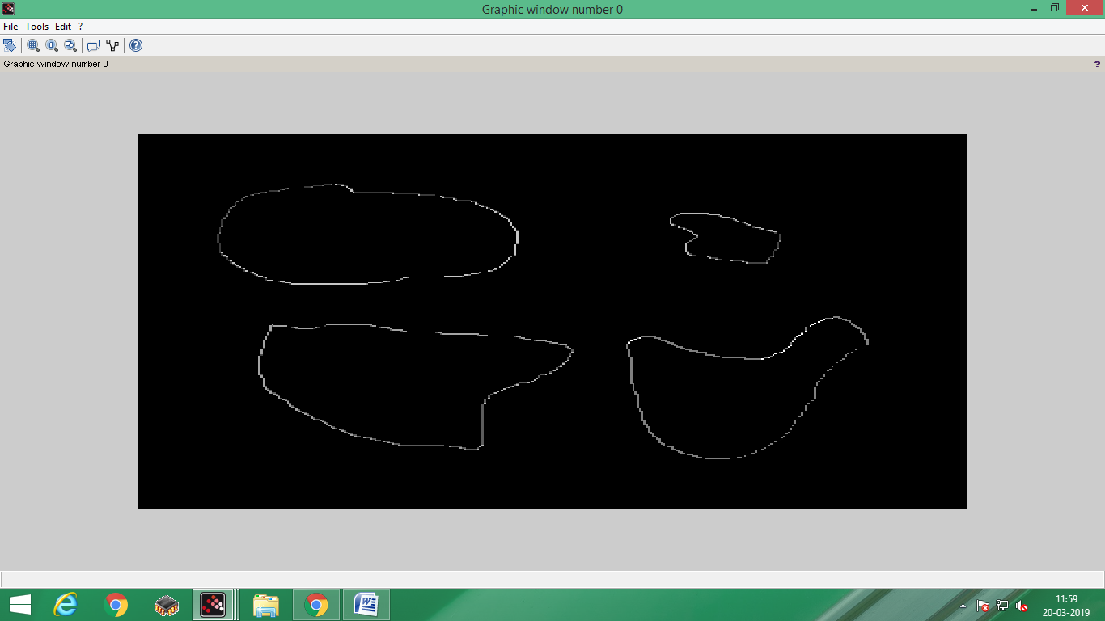

Prewitt operator

clc

clear all

close

A=imread('C:\Users\fy\Desktop\toyobjects.png');

[r c]=size(A)

A=double(A)

C2=[-1 -1 -1;0 0 0;1 1 1 ]

C1=[-1 0 1;-1 0 1;-1 0 1]

B1=zeros(r,c)

B2=zeros(r,c)

for i=2:r-1

for j=2:c-1

D=[]

for s=-1:1

for t=-1:1

D(s+2,t+2)=A(i+s,j+t)

end

end

B1(i,j)=sum(D.\*C1)

B2(i,j)=sum(D.\*C2)

end

end

E=[uint8(A) uint8(B1) uint8(B2)]

imshow(E)

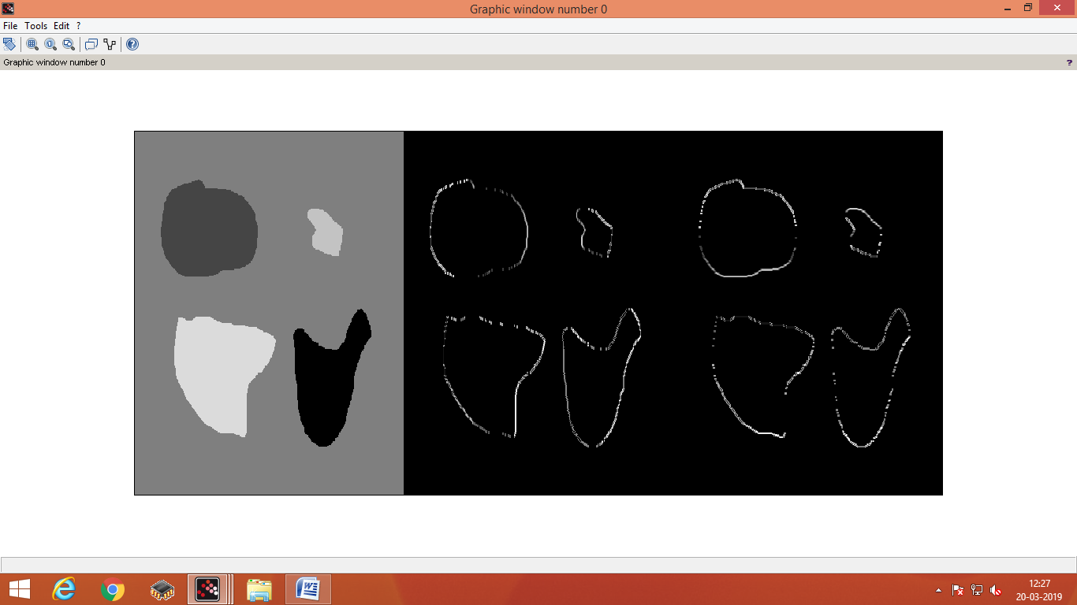

SOBELL OPERATOR

clc

clear all

close

A=imread('C:\Users\fy\Desktop\toyobjects.png');

[r c]=size(A)

A=double(A)

C2=[-1 -2 -1;0 0 0;1 2 1 ]

C1=[-1 0 1;-2 0 2;-1 0 1]

B1=zeros(r,c)

B2=zeros(r,c)

for i=2:r-1

for j=2:c-1

D=[]

for s=-1:1

for t=-1:1

D(s+2,t+2)=A(i+s,j+t)

end

end

B1(i,j)=sum(D.\*C1)

B2(i,j)=sum(D.\*C2)

end

end

E=[uint8(A) uint8(B1) uint8(B2)]

imshow(E)

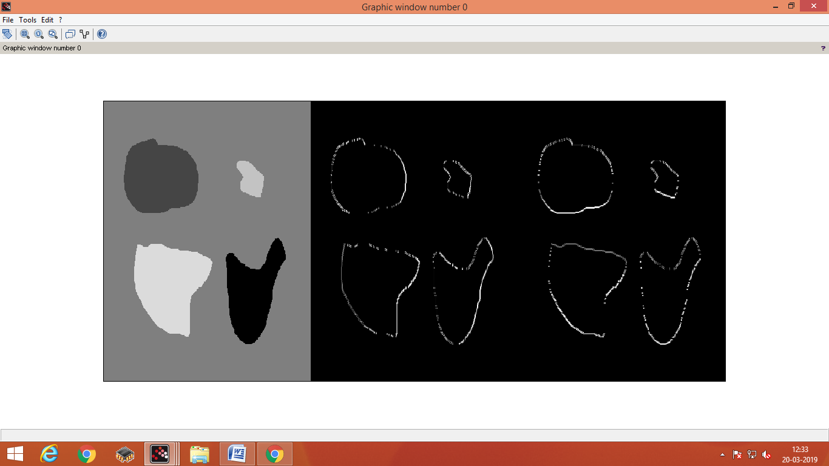

DIAGONAL

clc

clear all

close

A=imread('C:\Users\fy\Desktop\toyobjects.png');

[r c]=size(A)

A=double(A)

C2=[0 1 2;-1 0 1;-2 -1 0 ]

C1=[-2 -1 0;-1 0 1;0 1 2]

B1=zeros(r,c)

B2=zeros(r,c)

for i=2:r-1

for j=2:c-1

D=[]

for s=-1:1

for t=-1:1

D(s+2,t+2)=A(i+s,j+t)

end

end

B1(i,j)=sum(D.\*C1)

B2(i,j)=sum(D.\*C2)

end

end

E=[uint8(A) uint8(B1) uint8(B2)]

imshow(E)

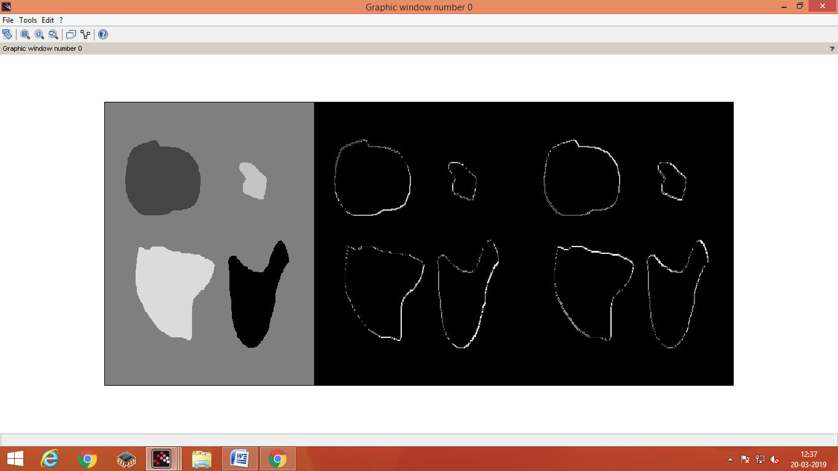

PREWITT DIAGONAL

clc

clear all

close

A=imread('C:\Users\fy\Desktop\toyobjects.png');

[r c]=size(A)

A=double(A)

C2=[0 1 1;-1 0 1;-1 -1 0 ]

C1=[-1 -1 0;-1 0 1;0 1 1]

B1=zeros(r,c)

B2=zeros(r,c)

for i=2:r-1

for j=2:c-1

D=[]

for s=-1:1

for t=-1:1

D(s+2,t+2)=A(i+s,j+t)

end

end

B1(i,j)=sum(D.\*C1)

B2(i,j)=sum(D.\*C2)

end

end

E=[uint8(A) uint8(B1) uint8(B2)]

imshow(E)

